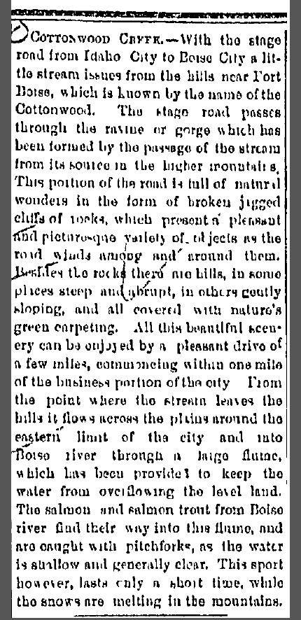Tri-Weekly Statesman; April 5, 1879

