[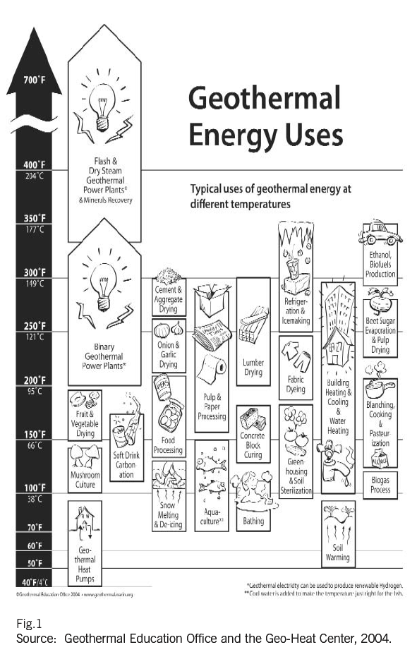](http://www.google.com/url?sa=i&rct=j&q=&esrc=s&source=images&cd=&ved=0ahUKEwj_1fvUivjUAhWG14MKHQVLBEEQjRwIBw&url=http%3A%2F%2Ftheearthproject.com%2Feverything-geothermal-energy%2F&psig=AFQjCNGQrHUBLd5wCNapJ9FrJ7FWn7E_Fg&ust=1499548196625813)

**GEOTHERMAL POTENTIAL**

[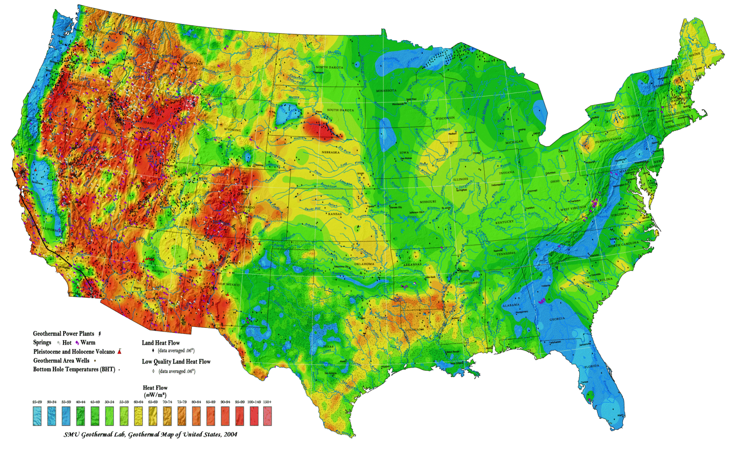](http://www.google.com/url?sa=i&rct=j&q=&esrc=s&source=images&cd=&cad=rja&uact=8&ved=0ahUKEwj42IDyi_jUAhUHxoMKHc8pAWcQjRwIBw&url=http%3A%2F%2Fpages.mtu.edu%2F~hamorgan%2Fbigideaswelcome.html&psig=AFQjCNF75QzMDHdFj0PEzYpXCp0dE2uWfw&ust=1499548544882146)

THERMAL GRADIANT

[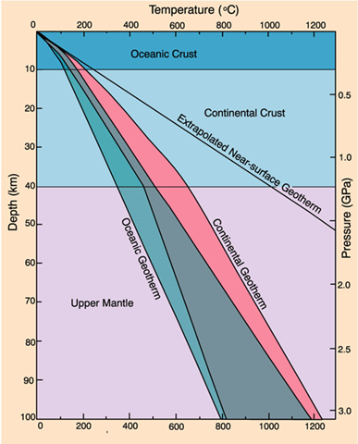](https://www.google.com/url?sa=i&rct=j&q=&esrc=s&source=images&cd=&cad=rja&uact=8&ved=0ahUKEwjrnJmQkPjUAhVszoMKHV2HCtQQjRwIBw&url=https%3A%2F%2Fwww.quora.com%2FWhy-is-Geothermal-Gradient-steeper-in-the-Oceanic-Crust-if-majority-of-the-Radioactive-elements-are-concentrated-in-the-Continental-Crust&psig=AFQjCNF2qLOZKfAidiAPpYSF4jgWL80vug&ust=1499549671950821)

**Warm Springs Water District**

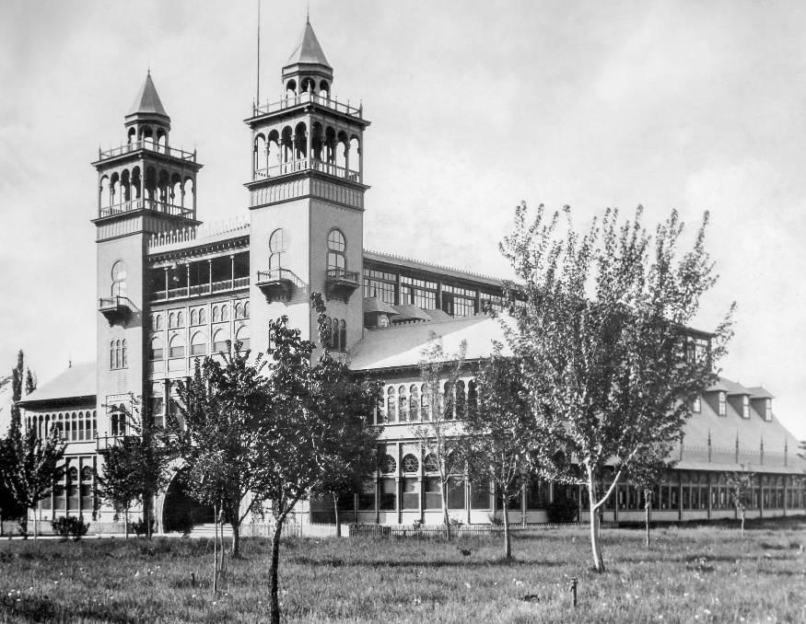

[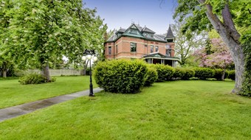](http://www.google.com/url?sa=i&rct=j&q=&esrc=s&source=images&cd=&cad=rja&uact=8&ved=0ahUKEwjRiKuIkfjUAhVr_4MKHRb0CXMQjRwIBw&url=http%3A%2F%2Fwww.ktvb.com%2Fnews%2Flocal%2Fhistoric-warm-springs-mansion-on-market-for-first-time%2F444235016&psig=AFQjCNGEj-UjTMFFgd7JkOdMyHhKR9lHTw&ust=1499549947379024)

**Kelly Hot Springs**

[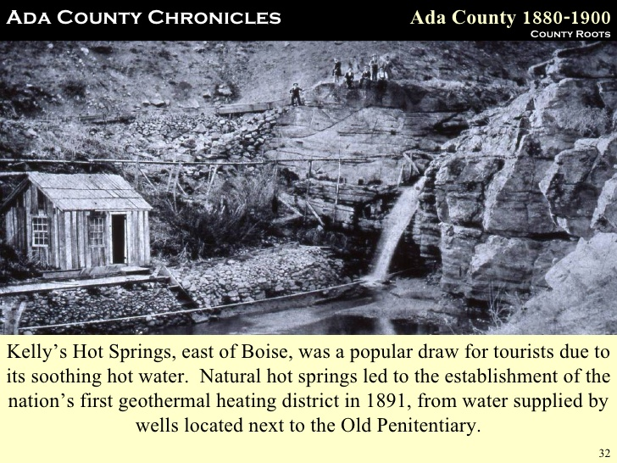](https://www.google.com/url?sa=i&rct=j&q=&esrc=s&source=images&cd=&cad=rja&uact=8&ved=0ahUKEwjGrO3nkvjUAhXi1IMKHfZ3AssQjRwIBw&url=https%3A%2F%2Fwww.slideshare.net%2Fklimer%2Fada-county-chronicles&psig=AFQjCNH3oCYu8FDVHnIeG4vOCKP4MuTkaw&ust=1499550352854005)

Warm Springs Resort (now The Springs)

