When planning your field trip, consider the following:
Learning Objectives: Students will learn basic water quality and hydrology field procedures, including measuring stream discharge and water quality parameters, and identifying aquatic macroinvertebrates.
Site Selection: We recommend that you select a water body as close to your school as possible to reduce travel time and facilitate more frequent monitoring throughout the year. This can also reduce the stress and coordination of taking students out of other classes. In addition, when selecting a site you should look for sites with public access that is easily accessible; locations where local professionals can join; and sites that can be compared (e.g., up and downstream of a pollution source or comparing two different water bodies).
Time Requirement: If your site is within walking distance, the time requirement can be as little as 45-90 minutes. If bussing is required, a half or full day in the field will be necessary.
Bus/Departure: Request your bus early so that there are some available!
Date: The water quality field trip is best at the beginning of the year (September or October) to prepare students for the rest of the year. Do wait at least a couple weeks from the first day of school so that you have time to prepare students for the trip with background research, preparatory lessons, and hypothesis development.
Materials Needed: Water quality testing kits, including dissolved oxygen ampoules (CHEMetrics K-7512), pH strips (Hach #2745650), thermometers (Forestry Suppliers), bug viewer, ice cube tray, tweezers, macroinvertebrate identification cards, transparency tube or Secchi disk, tape measure, tennis ball, stopwatch, Wolmanato, agendas, reflective writing worksheet. Water quality monitoring kits can be checked out from the UI Community Water Resource Center in Coeur d’Alene (contact Marie Pengilly mpengilly@uidaho.edu ). If you have supply funds available, you can also purchase a kit from the UI CDA Center.
Potential Collaborators:
Coeur d’Alene Area:
- Kat Hall, Lands Council, khall@landscouncil.org
- Laura Laumatia, Coeur d’Alene Tribe, llaumatia@cdatribe-nsn.gov
- Marie Pengilly, UI CDA Community Water Resource Center mpengilly@uidaho.edu
- Steve Kolb, Twin Lakes Improvement Association, kskitroom@aol.com
- Sid Fredrickson, Coeur d’Alene Wastewater Treatment Plant, SIDF@cdaid.org
- LeAnn Abell, Bureau of Land Management, Blackwell Island, labell@blm.gov
- Phil Cooper, IDFG, phill.cooper@idfg.idaho.gov
- Jamie Brunner, IDEQ, jamie.brunner@deq.idaho.gov
- Angelo Vitale, Coeur d’Alene Tribe, ajvitale@cdatribe-nsn.gov

Palouse Area:
- University of Idaho graduate students, e.g., Kathleen Torso tors4488@vandals.uidaho.edu
- Sheila McAtee, Environmental Technician, IDEQ, Sheila.McAtee@deq.idaho.gov
- Tom Builtonen, Lead Forester, Bennett Lumber Company, Princeton, ID, 208-875-1121
- Randy Stevens, Implementation Coordinator, Palouse-Clearwater Environmental Institute, rstevens@pcei.org (can plan service learning activities)
- Tiffany Corrao, Twin Creeks Farm, Princeton, ID, twincreeksfarmidaho@gmail.com
- Steve Robischon, Palouse Basin Aquifer Committee, stever@uidaho.edu
- Chris Dixon, Paradise Creek Wetland, cdixon@uidaho.edu

Risk Management: Meet with, email or call other instructors before trip to go over flow of the day, instruction and safety considerations. Attention should be placed on risk management considerations. For example:
  - Terrain and location for field trip.
  - Student group size and supervision (instructor:student ratio)
  - Weather conditions and access to covered area and emergency medical facilities.
  - Making sure students have proper clothing, food and water.
Instruction/Recommendations: Introduce the equipment, methods and data sheets in class so students have some familiarity with what they will be doing. Consider having multiple sites for sampling at your location so that each group can collect their own samples.
Alignment with Standards:
NEXT GENERATION SCIENCE STANDARDS
HS-ESS2-5 – Plan and conduct an investigation of the properties of water and its effects on Earth materials and surface processes.
Science & Engineering Practices:
- Obtaining, Evaluating, and Communicating Information
- Planning and Carrying Out Investigations
COMMON CORE STATE STANDARDS
CCSS.ELA-LITERACY.RST.9-10.3 – Follow precisely a complex multistep procedure when carrying out experiments, taking measurements, or performing technical tasks, attending to special cases or exceptions defined in the text.
CCSS.ELA-LITERACY.RST.11-12.3 – Follow precisely a complex multistep procedure when carrying out experiments, taking measurements, or performing technical tasks; analyze the specific results based on explanations in the text.
IDAHO STATE SCIENCE STANDARDS
ISSS.9-10.B.1.3.1 – Measure changes that can occur in and among systems.
ISSS.9-10.B.1.3.3 – Measure and calculate using the metric system.
ISSS.9-10.B.1.6.2 – Utilize the components of scientific problem solving to design, conduct, and communicate results of investigations.
ISSS.9-10.B.1.6.3 – Use appropriate technology and mathematics to make investigations.
ISSS.9-10.B.5.1.1 – Analyze environmental issues such as water and air quality, hazardous waste, forest health, and agricultural production.

Field Trip Procedures:
- Meet and prep with co-instructors a week or two in advance to prepare materials and plan the schedule for the day. Attention should be placed on risk management considerations. For example:
  - Water safety
  - Student group size and supervision (instructor:student ratio)
  - Weather conditions and access to emergency medical facilities.
- On the bus discuss expectations for the day with the students.
- Upon arrival to the field trip location, introduce any visitors.
- Play “Oh Trout!” or some other activity to engage the students.
- Explain the plan for the day, making sure to point out bathrooms, lunch site, and sampling locations. Provide a refresher of what will be tested if needed. Activities for the day could include:
  - Macroinvertebrate sampling
  - Water quality testing
  - Flow measurements (if at a stream or river)
  - Collecting data for small group research questions
  - Fishing, kayaking or other recreation (if available)
  - Lunch
  - Reflective writing
  - Listening to local researchers, agency personnel or nonprofit employees speak about the location and their work
- Divide students into their groups.
- Distribute appropriate data sheets and handouts (see below).
- Send groups to their respective locations to begin their work.
- Make sure students collect any additional data that they need for their individual research questions.
- Re-group for lunch and/or at the end of the day (depending on your schedule) and de-brief the experience.
- Return to bus at the appropriate time, with time for bathroom break, etc. Board the bus.
- On the way home, distribute and have students complete the reflective writing.

Water Quality Cheat Sheet
Macroinvertebrate Pollution Tolerance
Pollution Intolerant = stoneflies, mayflies, caddisflies
Somewhat Pollution Tolerant = scuds, dragonflies, damselflies, gilled snails
Pollution Tolerant = aquatic worms, midge larvae, blackfly larvae, leeches, lunged snails, clams

Dissolved oxygen: Macroinvertebrates, fish and other aquatic life need it to breathe!

(mg/L) 5 6 7 8 9 10
7 mg/L: Trout spawning
6 mg/L minimum allowed by state standards; Trout growth and well-being
>5 mg/L needed for pollution intolerant macros
8 – 10 mg/L = ideal
<5 mg/L: pollution tolerant macros can survive

pH: How acidic or basic is the water? If it’s too extreme, aquatic life can’t survive!

1 acids 7 bases 14
6.5 – 7.5 Team Clean and trout like neutral pH!
6.5 – 9.0 State standard for aquatic life
7.5 – 9.0 Snails, clams, mussels
6.5 – 12.0 Plants
1.5 – 13.5 Bacteria
1.5 – 13.5 Bacteria
5.0 – 5.6 Rain water

Water Temperature:
Pollution tolerant macros survive at warmer temps
Trout and Team Clean need high D.O. to survive
Cold water holds more dissolved oxygen
Standard for cold water biota is 22C for any single measurement and 19C for daily avg.
So they want colder water and are considered cold water biota

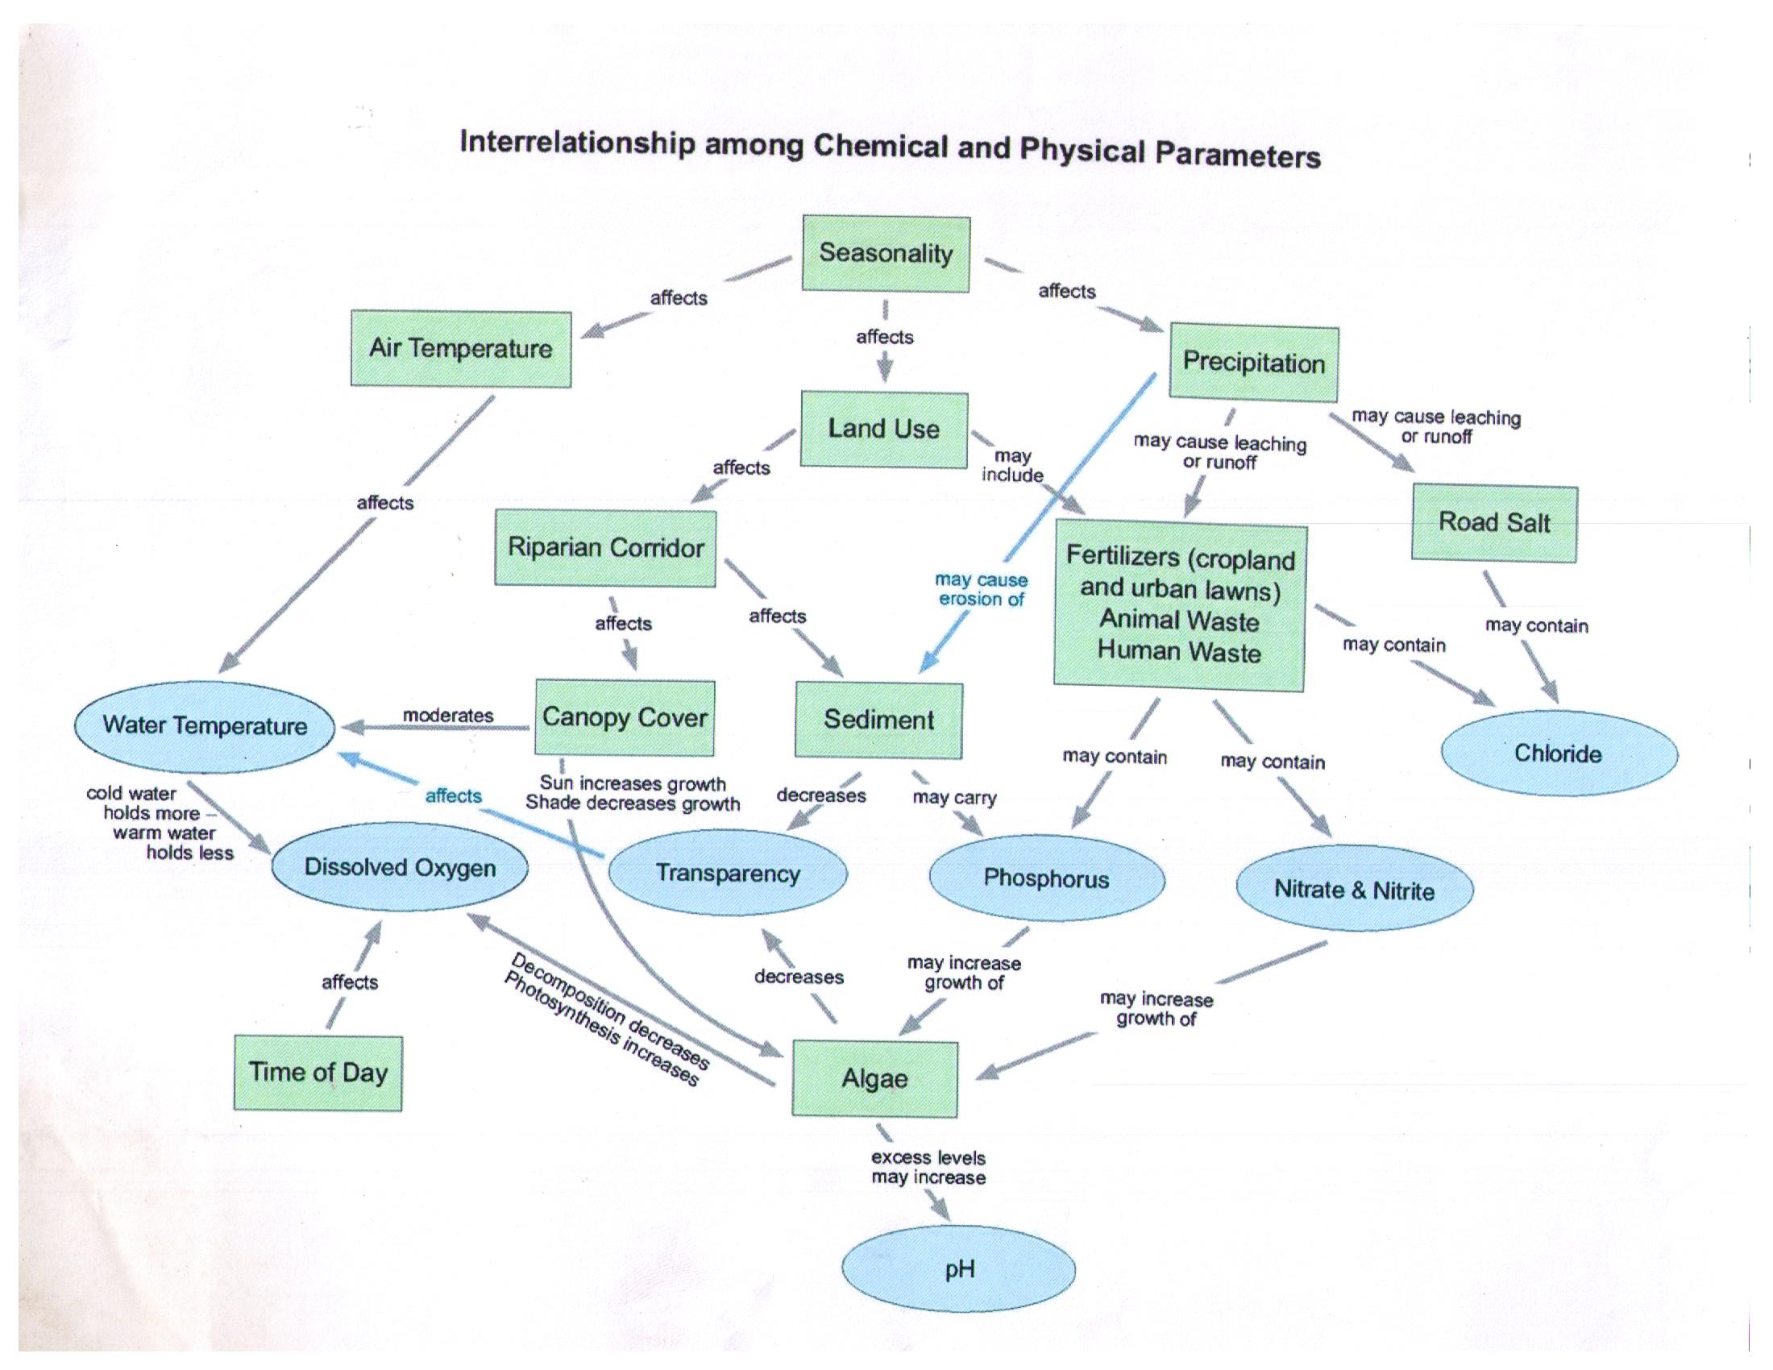

Date: Time:
Site Name:
Group Members:
Site Description- Take pictures!

Weather: (circle any that apply) Sunny Partly Sunny Cloudy Rain/Snow Windy Calm

Air Temperature: °Fahrenheit Water Temperature: °Fahrenheit

Transparency: cm pH: (circle one) 4 5 6 7 8 9

Dissolved Oxygen: (circle one) 1 2 3 4 5 6 7 8 9 10 11 12

Stream Width: meters Maximum Stream Depth meters

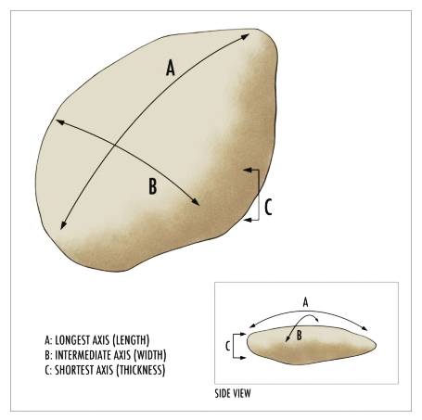
Wolman Pebble Count (along transect)
Size Class Dimension Tally
Silt/Clay 0 – 1 mm
Sand 1.1 – 2.5 mm
Very fine pebble 2.51 – 6 mm
Pebble 6.1 – 15 mm
Coarse pebble 15.1 – 31 mm
Very coarse pebble 31.1 – 64 mm
Small cobble 64.1 – 128 mm
Large cobble 128.1 – 256 mm
Small boulder 256.1 – 512 mm
Medium boulder 512.1 – 1024 mm
Remember! Always measure the intermediate axis (B) of rocks you pick up!
Large boulder 1024 mm and larger

Stream Banks (check all that apply)

Left Bank
- Eroding cut bank
- Vegetated cut bank
- Sloping bank
- Sand/gravel bar
- Rip rap
- Other:

Bank Condition (check one)
Left Bank
- Covered stable
- Covered unstable
- Uncovered stable
- Uncovered unstable

Channel shape (check one)
Left Bank
- Trapezoidal
- Rectangular
- Inverse trapezoidal
Right Bank
- Eroding cut bank
- Vegetated cut bank
- Sloping bank
- Sand/gravel bar
- Rip rap
- Other:

Right Bank
- Covered stable
- Covered unstable
- Uncovered stable
- Uncovered unstable

Right Bank
- Trapezoidal
- Rectangular
- Inverse trapezoidal

Canopy Cover: %
Estimate percent of canopy cover from the middle of stream along transect. Hint: take a picture!

Describe the riparian zone for each bank- What types of plants are growing (trees, shrubs, grasses, etc.)? How far back from the stream does it reach? Is there exposed soil? Riprap?

Describe adjacent land use- (Examples: agriculture, timber, prairie, park, campground, boating access, etc.)

Record evidence of human use along stream- Are there people swimming, boating, or playing? Are there fire pits, trash, roads, or paths? Describe everything you see.

Record all other land use practices in the watershed that could affect the stream-

MACROINVERTEBRATE SAMPLING
Look over your water quality results and the Water Quality Cheat Sheet.
- Does the water quality you measured provide the habitat needed for pollution intolerant macroinvertebrates (stoneflies, mayflies and caddisflies) to survive? Why or why not?

- Make a hypothesis about which groups or species of macroinvertebrates you expect to find here.

- Now go look for some bugs!

- After sampling… does your data support your hypothesis? Explain.

