A place-based climate change inquiry:

How might climate change affect water resources in the Intermountain west?

Climate change is a topic that has been given a lot of attention in recent history, especially when

One of the challenges with teaching about climate change is that the effects often seem far away and students can have a hard time understanding what it would mean for their community and their own lives. Place-based education aims to connect learning to things that students can study and observe in their own communities. Once students understand and connect to these concepts on a local scale it can be easier to connect them to broader, more global issues or things that are happening in far away places.

This unit explores how climate change might impact water resources in the regions of the country like the Intermountain West where much of the yearly water budget comes in the form of snow. One predicted outcome of a changing climate is that more of the precipitation in this region will come as rain instead of snow. This investigation poses the question “how would a change in the form of precipitation in winter affect how much water is available to us in the summer?” In this unit, students use physical models to explore how changes in the form of precipitation that we get (more rain instead of snow) will affect the timing of runoff and summer streamflow.

A second challenge with teaching about climate change is that it is a large, complex issue with solutions that are not very straightforward. After exploring how water resources in their community might be affected by climate change, students research the impacts of this change on their local water resources and work in teams to come up with adaptation and mitigation strategies for their community to address climate change and water resource issues. By having students explore some climate change adaptation and mitigation strategies, we hope to leave students feeling more empowered to make changes in their homes and at school that can positively impact climate change.

Climate Change and Water Resources in Snowpack-Driven Watersheds
As the concentration of CO2 in the atmosphere increases and global mean temperatures rise, there are potentially dramatic consequences for water resources management in the Intermountain west. Temperatures in the Western US have increased over the past 50 years (Hamlet and Lettenmaier, 2007). As temperatures rise, snowpack in the Intermountain West is decreasing because the proportion of precipitation falling as snow has decreased in sub-montane regions (Kowles et al, 2006) and snowpack is melting earlier, so that the percentage of total precipitation stored in the snowpack is decreasing (Pierce et al., 2008). These changes in the hydrologic cycle mean that the timing of snowmelt-driven streamflow has shifted forward (Stewart et al., 2005), and streamflow during the driest quartile of the year has decreased (Luce and Holden, 2009). Both of these consequences have implications for water resources management in the West (Abatzoglou, 2010). Changes in the timing and magnitude of runoff can lead to flooding as the storage capacity of reservoirs is exceeded. Irrigation-dependent farming, streamflow-dependent recreation like rafting and fishing, hydropower generation and fish habitat could all be impacted by decreased summer flows.

Student Preassessment
Before the activity, find out what students know about how the form of precipitation affects the shape of the hydrograph by having them draw a mock graph of how precipitation relates to streamflow in Intermountain west.

Activities
The activities described in this unit could be used as part of a larger unit on climate change or water resources. The first part of the unit has students experiment with a physical model to see how changes in the form of precipitation would change the shape of a hydrograph of a snowmelt driven basin. Elaboration and extension activities have students thinking about how a change in the shape of the hydrograph might impact their community from the perspective of various stakeholders who are dependent on water resources. A final piece

Materials:
- Oven rack liner (approx.. 18 inches x 15 inches) or other similar foil tray
- Funnel
- Containers for collecting and weighing snow and water (large yogurt containers work well)
- Spring scale
- 3 large yogurt containers
- Heat lamp
- Stopwatch

Set Up:
Construct watersheds out of foil trays and funnels. Gently fold the foil tray so that it is narrow at the bottom and wide at the top with sloping sides (see picture). Secure the funnel to the bottom of the tray at the narrow end. Place this structure on a cardboard box (or similar structure) so that the whole thing is sloping. This represents a watershed and river drainage.
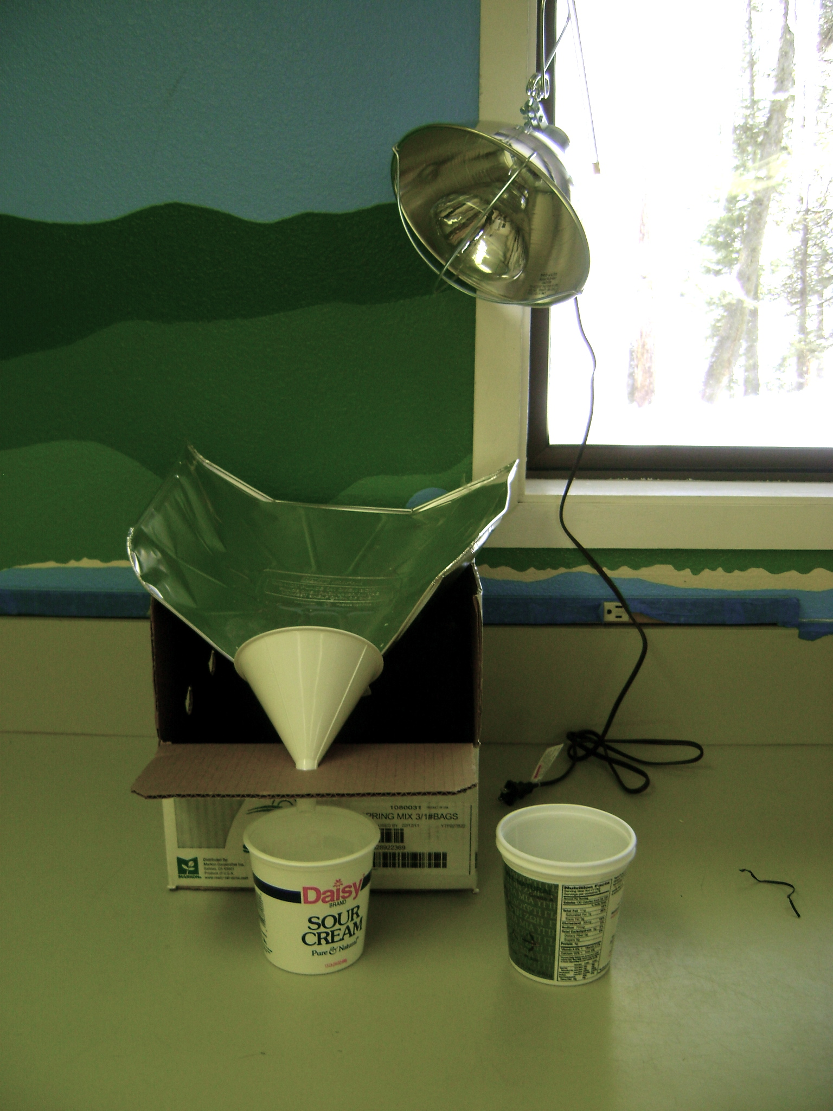
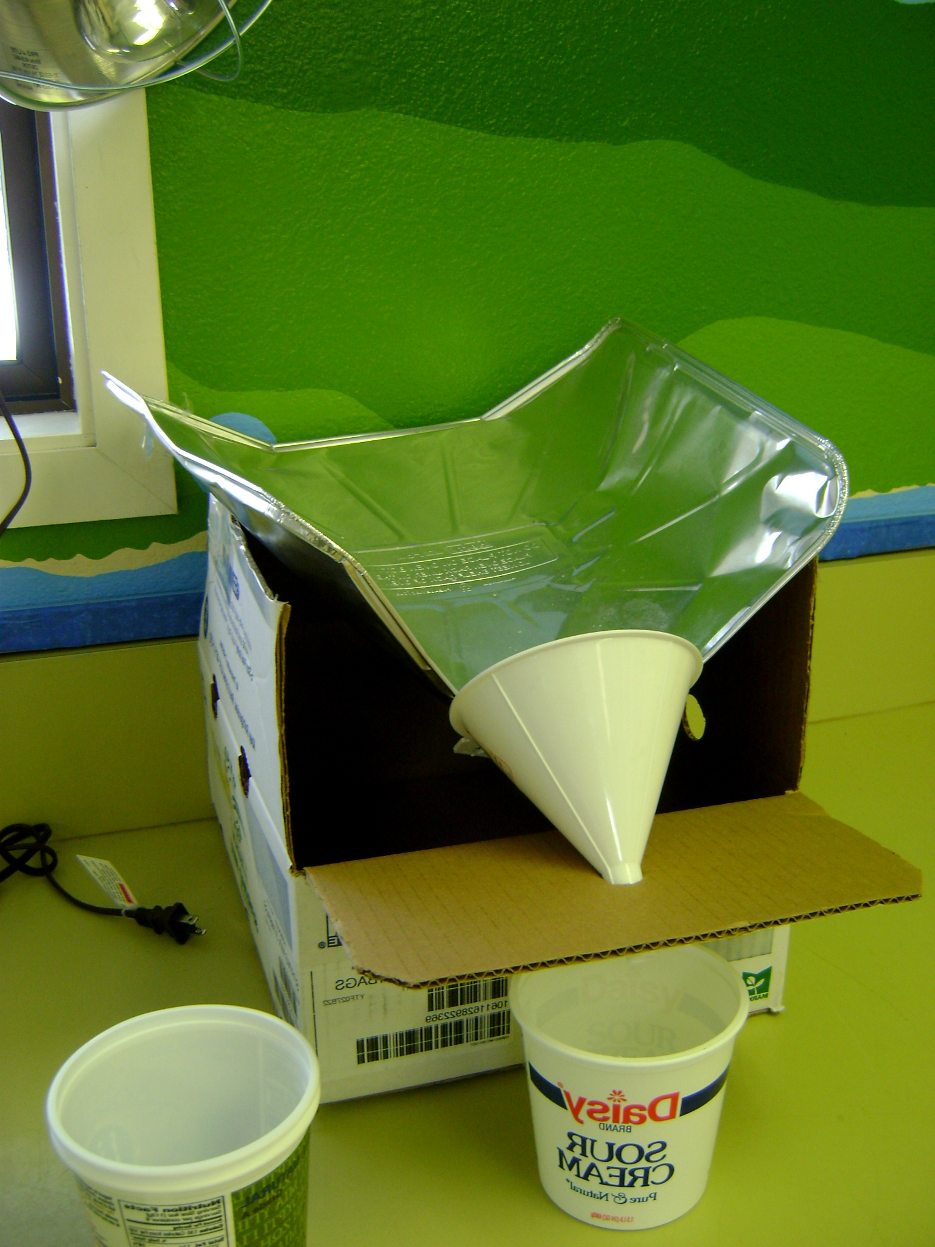

Prepare your catchment containers: Make a hole in the top lip of two of the yogurt containers so that they can be hung on the spring scale. Hang the empty container on the spring scale and zero it. Place one container under the spout of the funnel to collect water that comes down through the system. Students will use the second container to collect snow or water. The third container is used as a temporary catchment container (see instructions below).
Depending on your time and intended outcomes, either prepare a graph in advance or have students access and plot data showing historical averages for precipitation and streamflow in a river basin near you (see example below).

You might also include monthly average temperature so students can make inferences about the FORM of precipitation in each month.

Raw data can be accessed online from the following sources:
Precipitation: http://www.wrcc.dri.edu/coopmap/
SNOTEL: http://www.wcc.nrcs.usda.gov/snow/)
Streamflow: http://waterdata.usgs.gov/id/nwis/rt
Climate summaries: http://www.wrcc.dri.edu/Climsum.html

Data is not always easily downloadable in spreadsheet form so you may have to copy values into a spreadsheet that you create. Before you have students try to download data it is very helpful to go through all the steps yourself so that you know where they may have trouble.

After you have prepared a data set, copy one set of instructions and a datasheet for each student group.

PROCEDURE

ENGAGE
Get students engaged by having them think about the things that they like to do that are dependent on water in some form – do they like to ski? Raft? Fish? What other things in their community are dependent on water? [Is there hydropower? Do farmers use water to irrigate crops?]. Ask them to think about the water in their community. Where does it come from? What does the hydrologic cycle look like?

Look at a graph of average precipitation and streamflow for the Little Salmon River basin (or the basin you have chosen that is closer to home).

LITTLE SALMON RIVER | Oct | Nov | Dec | Jan | Feb | Mar | Apr | May | Jun | Jul | Aug | Sep
Average Precipitation in Tributary Basins | 2.3 | 4.6 | 4.9 | 4.9 | 4.5 | 4.4 | 3.7 | 3.1 | 2.4 | 1.1 | 1.2 | 1.5 | Bear Basin
 | 3 | 7 | 7.6 | 6.6 | 6 | 5.2 | 4.2 | 3.3 | 2.6 | 1.2 | 1.3 | 2.1 | Brundage
 | 2.8 | 6 | 6.2 | 5.7 | 5.5 | 5.7 | 4.3 | 3.6 | 2.3 | 1.2 | 1.2 | 1.6 | Squaw Flat
 | 2.5 | 6 | 6.7 | 6 | 5.7 | 5.3 | 3.8 | 3 | 2.2 | 1 | 1.1 | 1.4 | West Branch
Sum of Precipitation from Tributary Basins (in inches) | 10.6 | 23.6 | 25.4 | 23.2 | 21.7 | 20.6 | 16 | 13 | 9.5 | 4.5 | 4.8 | 6.6 | 4 Trib Basins
AVG STREAMFLOW in the Little Salmon River (in CFS) | 230 | 368 | 311 | 319 | 368 | 652 | 1290 | 2360 | 2320 | 660 | 253 | 218 | Little Salmon River
Average Temperature (in F) in McCall | 40 | 29.5 | 19.6 | 19.5 | 21.2 | 27.9 | 36.1 | 45.7 | 52.6 | 62.2 | 59.7 | 50.7

Start by asking students to look at this graph of average precipitation in a local river basin and ask them to think about the form that the precipitation takes [Historically, in this basin we have gotten as much as 80% of our precipitation in the form of snow. You can see that the winter months get the most precipitation and that by summer there is relatively little].

Discuss climate predictions for the Intermountain west – scientists are predicting under climate change scenarios more of our precipitation will come as rain instead of snow.

Tell students that we will be exploring the question “how would a change in the FORM of precipitation affect the shape of the hydrograph?” A hydrograph is a graph that shows seasonal variation in the volume of water flowing in a river or stream. So, in other words, if we get more of our precipitation as rain instead of snow, how will that change the amount of water in our streams throughout the year?

EXPLORE
Students will experiment with two different precipitation scenarios – precipitation patterns for the recent historical climate record (past 50 years), and for a warmer climate where more precipitation falls as rain.

Instructions for students:
- Using a large yogurt container, collect approximately half a container of snow
- Determine the mass of the snow in your container using a spring scale
- Add or remove snow until you have a mass that is approximately equal to the mass indicated in the snowfall data for the first month of our test (October)
- Add the snow to your foil tray “watershed” in a uniform way, covering as much of the tray as possible.
- Wait 3 minutes (use the stopwatch to time the trial). During these 3 minutes you can collect snow for your next “month”, start writing out these procedures in your lab notebook and make a hypothesis about how the shape of the hydrograph will change.
- At the end of 3 minutes, weigh the water that is in the catchment container. This represents streamflow for the month of October. Record this number in the streamflow cell for October on your datasheet and report your number to your teacher. While you are weighing the streamflow for this month, use a separate temporary container to catch any water that continues to flow.
- Transfer the water for October into the Reservoir container. Replace the original catchment container under the funnel, and add any water from the temporary container into your weighing container.
- Repeat steps 1 – 7 for the month of November, December and so on. When you get to a month that has a volume of rainwater you can either weigh out the mass or measure it by volume.
- When you get to the month of March, turn on your heat lamp to simulate the change in angle of the sun that leads to more solar gain and warming (seasonal change).

Test 1: Current climate precipitation pattern
 |  | Oct | Nov | Dec | Jan | Feb | Mar | Apr | May | Jun | Jul | Aug | Sep
TEST 1 | SNOW | 50g | 90g | 100g | 100g | 90g | 90g
 | RAIN |  |  |  |  |  |  | 70cc | 60cc | 50cc | 20cc | 20cc | 30cc
 | TOTAL | 50cc | 90cc | 100cc | 100cc | 90cc | 90cc | 70cc | 60cc | 50cc | 20cc | 20cc | 30cc

After completing your first test, use the data table below to run a second test. This second test has a mix of rain and snow in several of the months so you will be adding both snow and liquid water.

Before you start the second test, answer the following question in your lab notebook: How do you think the shape of your hydrograph will change in this test?

Test 2: Climate change scenario – same overall precipitation, but more of it is falling as rain instead of snow
 |  | Oct | Nov | Dec | Jan | Feb | Mar | Apr | May | Jun | Jul | Aug | Sep
TEST 2 | SNOW | 50g | 90g | 50g | 50g | 50g | 45g | 0g | 0g | 0g | 0g | 0g | 0g
 | RAIN |  |  | 50cc | 50cc | 40cc | 45cc | 70cc | 60cc | 50cc | 20cc | 20cc | 30cc
 | TOTAL | 50 | 90 | 100 | 100 | 90 | 90 | 70 | 60 | 50 | 20 | 20 | 30

As students run their experiments and collect their streamflow data, enter their data into an Excel spreadsheet with a graph tied to the data (see attached Excel file for a template).

EXPLAIN
Have students explain the changes they see in the shape of the hydrograph. What do they observe? How has streamflow / discharge been affected by a change in the form of precipitation? (If all goes well, they will have seen an earlier and higher volume runoff and decreased summer streamflow).

ELABORATE
Have students work in their groups to brainstorm the water resources and water uses that their community is dependent on. Possible examples include rivers for fishing, boating, fish habitat, hydropower, irrigation, etc.

Divide students into “Expert Groups” to have them focus on four different “sectors”: ecology, recreation, hydropower and agriculture. Have students use internet resources to come up with impacts of earlier runoff and decreased summer streamflow on their sector, in their community. The Climate Impacts Group at the University of Washington has a summary of climate change impacts on various sectors that could be used as a discussion tool. After groups have researched the impacts on their sector, have the expert groups come up with a short presentation to teach the rest of the class about their “sector”.

The United States Global Change Research Program has a very useful website that summarizes climate change impacts by region and by sector. It can be found here:
http://www.globalchange.gov/publications/reports/scientific-assessments/us-impacts

Some of the impacts that students might find for the Pacific Northwest include:
- Hyrdropower impacts: less water for generating hydropower in the summer months
- Ecological impacts: salmon habitat is impacted as water temperature rises and streamflow decreases
- Irrigation: potential flooding in spring as earlier runoff fills reservoirs to capacity and water needs to be released. Less water available in late summer.
- Recreation: changes in the timing of peak recreation season may not coincide with school breaks. Economies that depend on recreation based tourism (rafting, fishing) may find that their peak season happens at a different time of the year and does not last as long.
After each expert group has presented, divide the class into new groups comprised of members of each of the expert groups. Have them brainstorm solutions that balance the needs of each sector. Questions to guide your students include: What tradeoffs could each sector make? How will you decide who gets how much water? What engineering solutions might be used to help communities mitigate or adapt to climate change impacts (think about different ways of storing water, more efficient water infrastructure)? What behavioral solutions could communities use to mitigate or adapt to climate change impacts (think about ways to encourage people to use less water, different crops that could be planted, other kinds of recreation).

WRAP-UP
Discuss possible actions that students can take to mitigate climate change. Some great resources for helping students come up with ways to address global climate change can be found at http://youngvoicesonclimatechange.com/

You may want to include a discussion of the difference between technological solutions to address climate change versus focusing on changes in human behavior. Which strategy do students think is more effective, and why?

EVALUATE
Have students discuss limitations of the model that they used to test the relationship between form of precipitation and summer streamflow. What was not accounted for? What other tests could they perform? What other questions could they ask?

EXTENSION
There are many possible extensions to these activities. You might have students perform additional experiments based on the new questions that they generate (changing the total amount of precipitation, changing the temperature of the watershed, adding dust or dark particles to explore the albedo affect, making the model more realistic by adding a spongy layer to that would mimic the affect of soil and infiltration).

Extensions for exploring the impact of climate change on the water resources in their community could include setting up interviews with community members whose livelihood is directly dependent on water, touring existing water resource infrastructure like dams and irrigation canals.

Why are we weighing the snow?

Scientists use the weight of snow to find out how much water is in it. We know that water weighs one gram per cubic centimeter at 1 atmosphere of pressure. If we weigh our container of snow and find that it has a mass of 50 grams, we know that we have 50 cubic centimeters of water! Try it out – measure out 50 cc of water and weigh it. Does it weigh 50 grams?

When scientists want to find out how much water is in the snow, it’s not really possible for them to take the mass of the entire snowpack. Instead, they weigh a sample in a known volume so that they can calculate the density of water in the snow.

We can calculate a density of water in snowpack by dividing the mass of our sample by the volume of the sampling container. For example, if our sampling container = 100 cubic centimeters (cc), and we have a mass of 23 grams (g), we divide 23 g / 100 cc and we get a density of 23g/100cc, or 23%.

Density in the snowpack can vary quite a bit, so it’s a good idea to either get a core sample that takes snow from all layers of the snowpack, or else take samples from each layer of the snowpack and average them to find the average density.

Once we have the density of water in the snowpack, we can calculate SWE (Snow Water Equivalent) by multiplying the density and the height of the snowpack. For example, if the height of our snowpack is 116 cm, and our density is 23%, we get a SWE of 116 cm x .23 = 26.68 cm. This means that if all the snow melted at once, the ground would be covered in 27 cm of water!

Student Instructions and Data Sheet
TEST 2 | Oct | Nov | Dec | Jan | Feb | Mar | Apr | May | Jun | Jul | Aug | Sep
SNOW | 50 g | 90 g | 100 g | 50 g | 50 g | 45 g | 35 g
RAIN |  |  |  | 50 cc | 40 cc | 45 cc | 35 cc | 60 cc | 50 cc | 20 cc | 20 cc | 30 cc
TOTAL PRECIP | 50 g | 90 g | 100 g | 100 g | 90 g | 90 g | 70 cc | 60 cc | 50 cc | 20 cc | 20 cc | 30 cc
STREAMFLOW

TEST 1 | Oct | Nov | Dec | Jan | Feb | Mar | Apr | May | Jun | Jul | Aug | Sep
SNOW | 50 g | 90 g | 100 g | 100 g | 90 g | 90 g
RAIN |  |  |  |  |  |  | 70 cc | 60 cc | 50 cc | 20 cc | 20 cc | 30 cc
TOTAL PRECIP | 50 cc | 90 cc | 100 cc | 100 cc | 90 cc | 90 cc | 70 cc | 60 cc | 50 cc | 20 cc | 20 cc | 30 cc
STREAMFLOW

Instructions
- Using a large yogurt container, collect approximately half a container of snow
- Determine the mass of the snow in your container using a spring scale
- Add or remove snow until you have a mass that is approximately equal to the mass indicated in the snowfall data for the first month of our test (October)
- Add the snow to your foil tray “watershed” in a uniform way, covering as much of the tray as possible.
- Wait 5 minutes (use the stopwatch to time the trial)
- At the end of 5 minutes, weigh the water that is in the catchment container. This represents streamflow for the month of October. Record this number in the streamflow cell for October on your datasheet and report your number to your teacher. While you are weighing the streamflow for this month, use a separate temporary container to catch any water that continues to flow.
- Transfer the water for October into the Reservoir container. Replace the original catchment container under the funnel, and add any water from the temporary container into your weighing container.
- Repeat steps 1 – 7 for the month of November, December and so on. When you get to a month that has a volume of rain water you can either weigh out the mass or measure it by volume.
- When you get to the month of March, turn on your heat lamp to simulate the change in angle of the sun that leads to more solar gain and warming (seasonal change).

