Habitat, Hatcheries, Hydroelectricity, and Harvest! Oh My!
Collaborative Planning in the Columbia-Salmon River Basin

Issue: We have the 4 H’s (Habitat, Hatcheries, Hydroelectricity, and Harvest) that cause problems with Salmon populations. The local Boise power company has hired the Army Corps of Engineers, a federal agency, to build a dam in the Columbia-Salmon River Basin to insure water security for growing populations and generate cheaper power. The Columbia-Snake River Basin was once the most productive salmon and steelhead watershed in the world - up to 30 million fish returned to spawn here each year, nourishing entire ecosystems, cultures and economies. Almost half of these fish began and ended their lives in the Snake River and its tributaries in central Idaho, southeast Washington and northeast Oregon.
Unfortunately, dams and habitat destruction have pushed salmon to the brink. Today, less than 1% of these native fish remain in the Columbia Basin. All Snake River salmon and steelhead are either extinct or listed for protection under the Endangered Species Act (ESA). The decline of these runs has harmed communities and environments along the coast from Alaska to California and inland to Idaho and Nevada. Looking at the views of the following stakeholders, how can we effectively manage Salmon populations and build a dam.

---------------------------------------------------------------------------------------------------------------------
Stakeholders

Salmon distributor: You work for a company that sells salmon to restaurants on a large scale. This provides you with a source of income. Restaurants only want salmon because it sells better than other types of fish. You currently source your fish from a salmon farm but people would pay more for native salmon.

Army Corps of Engineers: You have been hired by a power company that wants to build a dam on this river. You must file an Environmental Impact Statement before starting the project. There is a lot of negativity towards this project but you are just being hired to build the structure. This project will bring a lot of jobs to the area.

Nez Perce Tribe member: Your tribe has relied on salmon as a source of food for many generations. The future generations of the tribe will need to know how to catch fish in order to feed their families and the community comes together to teach the youth about the salmon. You recreationally fish this area regularly. Keeping the land natural and honoring the earth is very important to your tribe but jobs are hard to find in your area with the changing economy and the tribe is struggling with poverty.

Fruit farmers: Your family has owned a 3000 acre fruit farm for a few generations growing cherries, apples, pears, and more. Water and irrigation are necessary for them to be able to water their crops and without the usual spring flows of water coming down the river, there won’t be enough stored water to sustain the crops. Having a dam built would change the amount of water available at different times of the year. Without this source of income from the farm, your family won’t be able to support itself and many local grocery stores will lose a top provider of fruit.

Fisherman: Your family has been participating in summer fishing trips ever since you can remember. Your family gets good meals, fun times, and new experiences every time you go. Tradition drives your family values and you want to continue fishing with your family as many times as possible. Your family always fishes at a special spot and if a dam is put on the river, the salmon would no longer be able to reach this spot.

Idaho Power employee: You have been put in charge of finding a new, cheaper source of electricity for this area. Hydroelectric power is very affordable and available in this area. Your company is working with a team of engineers to build a dam on the river near by. This dam will not only bring cheap electricity to the area but it will provide the community with a lot of new jobs.

Collaborative Planning Instructions

- Get into a group with the same stakeholders
- Read the description of your stakeholder above in your group. Use computers, your chaperones and teachers to research more about your stakeholder, specifically their role in Idaho.
- Create a short 3 minute presentation of your values and interests and how you think you would manage the river as your stakeholder. Remember to think about social, political, ecological and economic issues.
- Present your research, interests and opinions to the rest of the group.
- After hearing from all the stakeholders, we will have to come to a decision about how to manage this river.
- Make sure to know your stakeholder well enough to share your interests and opinions.
- Work together as three collaborative teams composed of diverse stakeholders to negotiate and create a management plan.
- Present your plan to the other groups and hear their feedback.

Town Hall Meeting Instructions - Instructor Version - 80 min

- Introduction to activity, water and salmon issues and collaboration 10 min
  - Overview of activity
  - Show map (below)
  - Show video: http://www.idahostatesman.com/news/local/environment/article117920318.html/video-embed
  - What is collaboration? (see below) What are important skills to bring to a group collaboration? (similar to teamwork?)
- Set ground rules and break students into groups - 5 min
- Read the description of your stakeholder above in your group. Use computers, your chaperones and teachers to research more about your stakeholder, specifically their role in Idaho. 15 min
- Create a short 3 min presentation of your values and how you think you would manage the river as your stakeholder. Remember to think about social, political, ecological and economic issues. 5 min
- Organize group into one large circle. Each group has 3 min to present their research and interests to the rest of the group. Other stakeholder groups should be taking notes, maybe assign a notetaker? 20 min
- After hearing from all the stakeholders, we will have to come to a decision about how to manage this river.
- Break students into three collaborative teams, mixing up the different stakeholder groups. Work together in these collaborative teams to negotiate and create a management plan. This plan may or may not include a dam but should address the interests and concerns of each of the stakeholders. 15 min
- Present your plan to the other groups and hear their feedback. 10 min (3 min each team)

Debrief: 5 min
- Would a project like this have to continue holding stakeholder meetings throughout the project? Why or why not?
- Discuss the importance of holding a collaborative meeting like this one
- What challenges did your multi-stakeholder groups confront?
- Could students see this method being applied in their watershed? Why or why not?
- Can the students see any difficulties in trying to hold a collaborative meeting like this? Go into detail on why or why not.

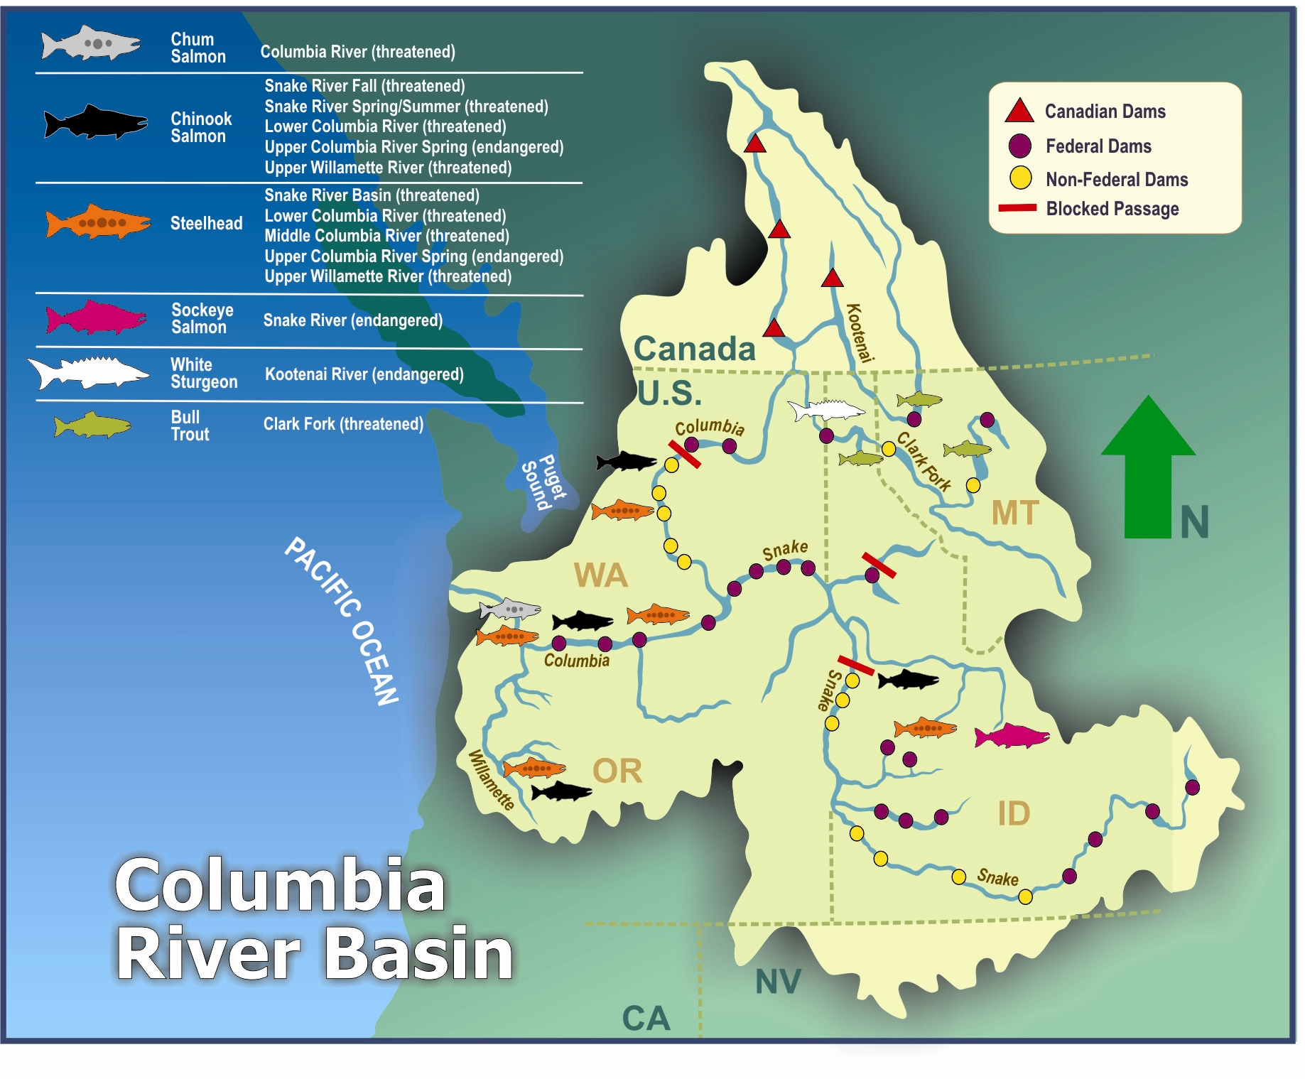
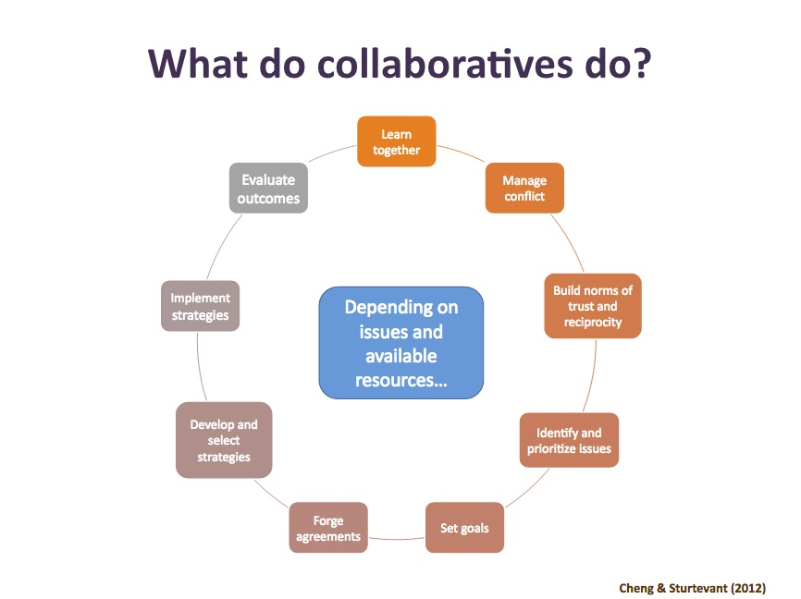
- A network of people and resource managers
- Representing different stakeholder perspectives or interests
- Comes together to pool resources and share power in order to achieve outcomes that could not be achieved independently

Articles
Salmon distributor: http://www.skunasalmon.com/news/skuna-bay-salmon-announces-new-pacific-nw-distributor-partner-adding-pacific-seafood-group-to-its-roster-of-exclusive-purveyors

Army Corps of Engineers:
http://www.spokesman.com/blogs/outdoors/2017/mar/27/spill-more-water-over-snake-dams-salmon-judge-tells-corps-engineers/

Environmentalist: http://www.wildsalmon.org/news/a-lawful-salmon-plan/idaho-statesman-saving-the-salmon-can-lead-to-a-long-lasting-northwest-economic-renewal.html

Nez Perce: http://www.nptfisheries.org/

Fruit Farmer: http://www.postregister.com/articles/food-home/2017/01/27/winter-has-harsh-impact-idaho-farming
http://www.idahopress.com/news/local/local-fruit-growers-farm-families-revive-produce-market/article_848bdfea-b627-5a16-821a-39b703219e9e.html

Fisherman:
http://www.idahostatesman.com/outdoors/fishing/article138147903.html
http://www.stamfordadvocate.com/news/article/Young-salmon-risk-gas-bubble-trauma-on-trip-to-11052566.php

Idaho Power: http://www.oregonlive.com/environment/index.ssf/2016/12/idaho_power_company_wants_to_n.html

