How Did That Get Into The River?
What’s A Watershed?

Overview:
Students will understand what a watershed is and how they live our lives affects the water they may use on a daily basis.

Keywords:
Watershed – All the land that drains water into a creek, river, lake, bay or ocean. The watershed is named
for the body of water into which it drains.
Runoff - An overflow of rainfall or snowmelt that cannot be absorbed by soil and vegetation
Landform - A physical feature, such as a hill, mountain, valley, plateau, river, lake, etc.
Ridge - The high points of a range of hills or mountains
Tributary - A stream feeding into a larger stream, lake, etc.

Subject:
Earth Science, Physical Science

Grade Range:
5th-9th Grade

Background:
This lesson is about understanding what a watershed is and how people can affect the water they use and see every day. When it rains, where does the water go? Does it seep into the ground? What happens to the water that lands on the pavement or buildings? This is what will be discussed through video and a hands-on exercise modeling a watershed. (www.fergusonfoundation.org), (Alice Ferguson Foundation, Hard Bargain Farm Environmental Center)

Common Core/Idaho Content Standards:
Idaho Content Standards Grade 5-6 Science & Earth Science 8-9: Standard 5 - Personal and Social Perspectives; Technology

Goals:
The students will be guided through a lesson on what is a watershed and how it affects them through a video and a hands-on activity demonstrating the flow of water through a watershed and how might pollutants get into the waterways around them.

Objectives: Students will understand…
- The term watershed
- The use of a model to show an understanding of the term “watershed”
- How pollution can get into our waterways through runoff

Materials:
Computer, with internet access and projection ability
“What is a Watershed” worksheet (1 per individual)
Student Sheets – Crumpled Paper Watershed (1 per group or individual)
2 pieces of plain scrap paper (8 ½ x 11)
Spray Bottle (1 per group)
Water
Water-based markers (blue, brown, black, green, orange)
Set-up:
Indoors for video; Indoors (on a desk/table), Individual/Student Pairs/Groups

Time/Duration:
60-75 minutes

Procedure:
- Say, “Do you ever wonder where all the water goes when it rains? You see water absorbed into the ground by trees, grass, but where does the water go when it lands on paved roads, buildings or the trash in your back yard?”
- Say,” That’s what we are going investigate today. First, we will discuss what a “watershed” is and a few key terms that will help us with today’s lesson.”
- Pass out “What is a Watershed” paper to each student. Go over “Watershed” definition and vocabulary.
- Watch “Way of a Watershed” Video (http://fergusonfoundation.org/hbf-kids-zone/way-of-a-watershed). Discuss and answer questions as it pertains to the video and “What is a Watershed?”
- Tell students, “Clear everything off your desks as this activity could get them wet.” Pass out Student Sheets – Crumpled Paper Watershed, one sheet of 8 ½ x 11 paper, and markers to each student/group.
- This activity can be conducted in two different ways:

Teacher-directed - You can work through the instructions on the Student Sheets as a class, with the teacher giving instructions orally and demonstrating the steps as necessary.

Self-Directed: Students can read and follow the instructions on the Student Sheets at their own pace, with the teacher monitoring student progress throughout the activity and giving assistance where necessary.

- Discuss student results, and answers to the questions in the Analyze Your Data and Draw Conclusions section of the Student Sheets.
- Use completed Student Sheets for evaluation.

Additional Resources/Family/Community Connections:
The following websites are resources someone could use to get more information regarding this topic or lesson.
www.BoiseEnvironmentalEducation.org
http://fergusonfoundation.org
http://fergusonfoundation.org/hbf-kids-zone/the-water-cycle
http://www.boisewatershedexhibits.org

Student Sheets – Crumpled Paper Watershed

Set Up Experiment #1
- Crumple up the piece of paper your teacher gave you, and then smooth it back out most of the way. It should still be a bit crumpled, showing small ridges (high points) and valleys (low points).
- Imagine that this paper is a section of land, and find the ridgelines
(the tops of the fold-lines).
- Use a washable blue marker (not permanent) to color along the
ridgelines on your “land.”

Make Your Hypotheses
You are going to “rain” on your landform. Answer the following
questions to make your hypotheses before conducting the experiment.

- What do you think will happen to your land when it “rains?”

_______________________________________________________

- What will happen to the blue ridge lines you colored?

_______________________________________________________

- Where will the “rainwater” travel?

_______________________________________________________

Student Sheets - Crumpled Paper Watershed

Conduct the experiment.
- Use a spray bottle of water to create a “rainstorm” over your land.
You want to create gentle sprays of mist.
2. Observe what happens after every misting.
3. As your “rainfall” accumulates, observe the pathways where the
excess “rainfall” travels.

Observations.
In the space below, record your observations about what happened (Use words and pictures if you wish).

Answer the following questions or complete the activities to analyze
and draw conclusions about your data.
- Explain how your hypotheses were or were not accurate.

- How did the “rainfall” travel over your land?

Student Sheets - Crumpled Paper Watershed

- Where did the water collect? Explain why this happened.

- Find an area on your land where water collected. This is a lake, and you get to name it! My lake is Lake _________________.

- Look for the major stream running into your lake. Name this stream as well. My stream is called _______________________________.

- This stream may have several tributaries (small streams which run into the larger stream). How many does your stream have? __________.

- With your finger, trace your stream all the way back up to where it starts at the top of the ridge. (This should be a path of blue ink.) When you reach the top, this is the edge of the watershed for your stream and lake.

- Trace the entire edge of the watershed with your finger, by following the ridgeline. This will be something like tracing the edge of a bowl.

All of the inside, downward-sloping area you have just outlined is the watershed for your stream and lake.

- Draw a picture of your watershed below. Label your stream and lake.

10. How many other watersheds can you find on your “land?” ________.

11. How would you define the word “watershed?”

Student Sheets -- Crumpled Paper Watershed

Set Up Experiment #2

- On a fresh sheet of paper, draw some of the ways people use the land.
Include a house/community, farm, factory, and some streets/highways.
2. Using the color key below, color your areas with markers.

Use this color… | To Represent | What might be on this land that you wouldn’t want in the water?
Green | Farms
Black | Landfills & Factories
Orange | Houses & Streets

3. Crumple this paper, and smooth it in the same way you did the first one.
4. Use the blue marker to trace the ridgelines on this paper.

Make hypotheses about what you think will happen when you “rain” on your land this time.

Gently mist your new land with water from your spray bottle. Observe what happens, and how the water travels.

Record your observations (in words and pictures) here.

Student Sheets -- Crumpled Paper Watershed

Answer the following questions to analyze and draw conclusions about your data.

- What happened in your second experiment?

2. What do you think the colors could represent in real life?
• Green = _________________________________________
• Black = ___________________________________________
• Orange = __________________________________________

3. Where were the colors in the end?___________________________

- Where are you in this watershed? What kinds of pollution do you think you
add to the watershed?

Student Sheets -- Crumpled Paper Watershed

Circle the letter of the correct answer for each of the following questions to show you understand the information in this activity.

1. Choose the best description for the watershed of a stream:
a. the water of a stream and all the tributaries that feed into it, including wetlands

b. all the land that slopes toward the stream and drains rain and melting snow into the stream

c. a large wet area of land that completely surrounds the stream.

2. You are hiking along a trail in a hilly countryside. You know that you have reached the watershed of a different stream because:
a. the ground changes from soggy soil to dry forest

b. you can see another stream

c. you are standing on a high spot and the land starts to slope downward again

What is a Watershed?

A watershed is an area of land that drains into a body of water. When rain falls it lands on trees, grass, homes, roads, farms, parking lots, gardens, schools and more. Natural surfaces absorb that water, but paved surfaces, buildings, and landscaped plots send most of the water flowing over land, downhill to nearby streams. We call that water runoff, and it carries with it anything that’s on the land – soil, fertilizer, trash and more. In our region, all of those streams eventually meet the Boise River. You live in the Boise Watershed and what you do on land affects the river!

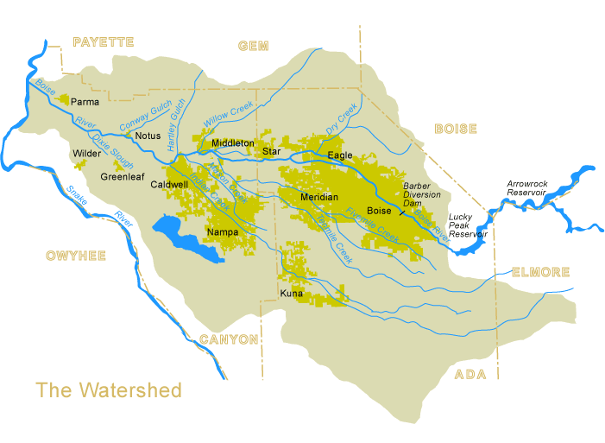
http://www.lowerboisewatershedcouncil.org/01_who-we-are/watershed-map.html

Watershed – All the land that drains water into a creek, river, lake, bay or ocean. The watershed is named
for the body of water into which it drains.

Runoff - An overflow of rainfall or snowmelt that cannot be absorbed by soil and vegetation

Landform - A physical feature, such as a hill, mountain, valley, plateau, river, lake, etc.

Ridge - The high points of a range of hills or mountains

Tributary - A stream feeding into a larger stream, lake, etc.

